**COMSATS University Islamabad, Lahore Campus**

**CSC-495 Game Development**

**Lab 11-12 TO DO List**

1. Add Terrain, Night lights and FPS Controller in a scene, just like in lab 10
2. Now add a bullet in the scene, and instantiate it in a script added to BulletController (Empty Object).

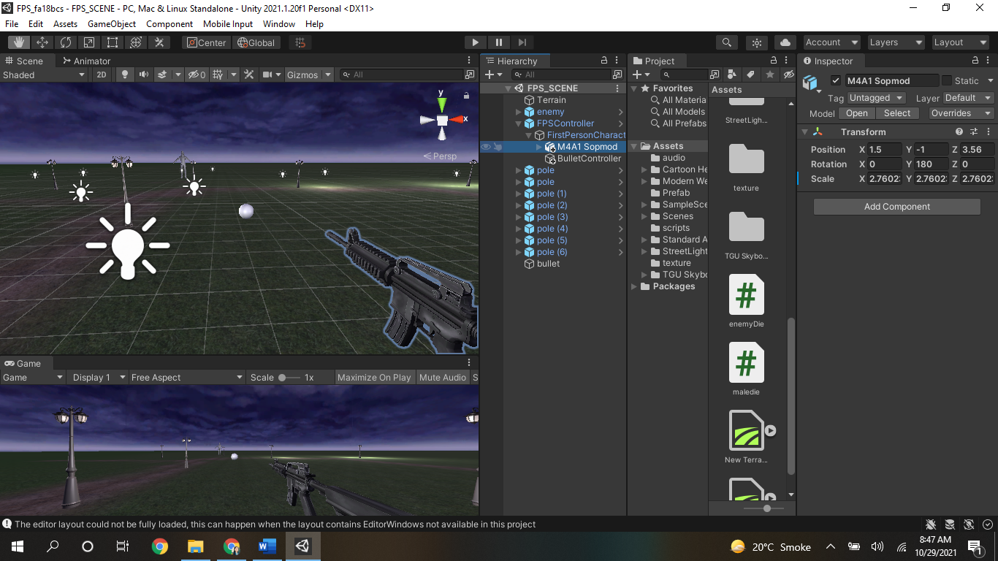

1. Add a Machine to the FPS Character as its child. (Machine gun link: <https://assetstore.unity.com/packages/3d/props/guns/modern-weapons-pack-14233>)
2. Make sure BulletController is the child of FPS Character and position should be set from where you want to fire (instantiate) the bullet. For example give it same x, y, z position of the gun and move forward its z position a bit.
3. Add BulletLauncher.cs script to the BulletController where bullet should be passed as gameObject below the script in BulletController inspector.

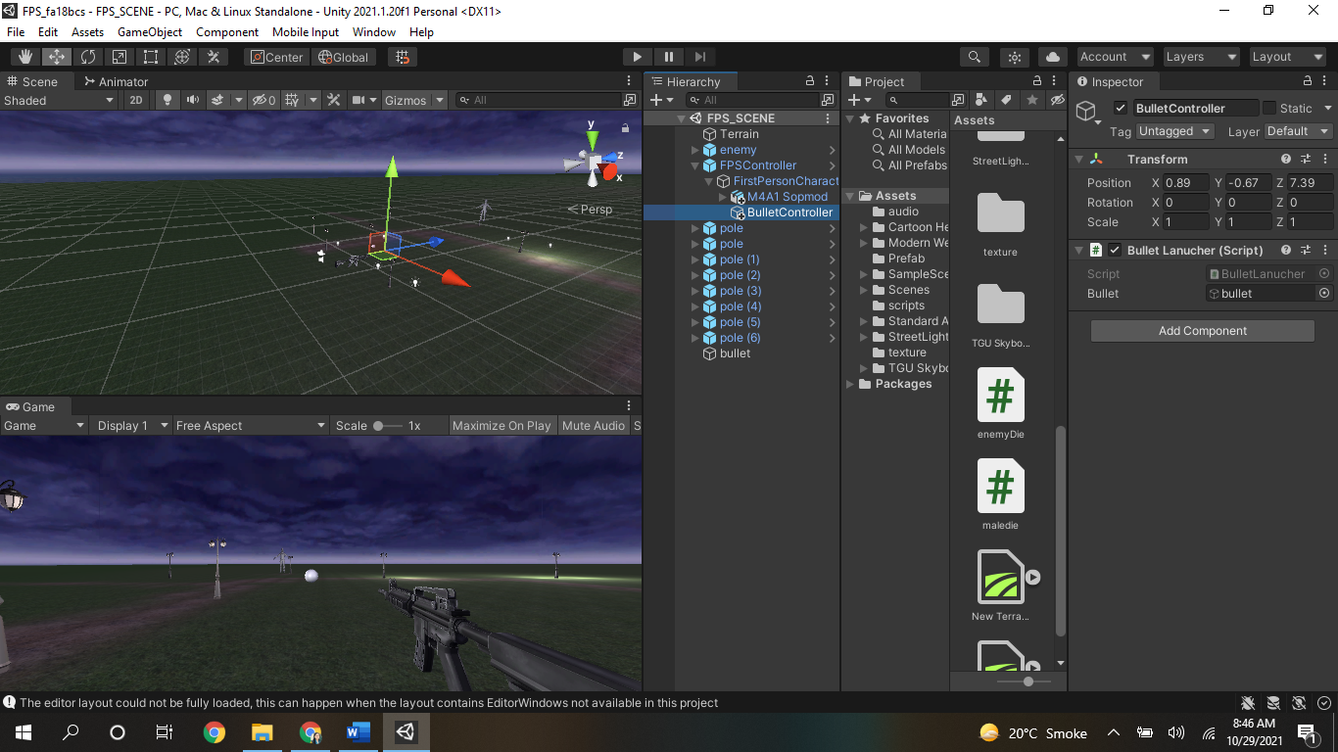

1. Add BulletScript to the bullet, which will move it through either Translate or AddForce.
2. Make sure bullet has Rigidbody with disabled gravity.
3. Place AIThirdPerson character from standard assets into the scene
4. Rename it as enemy
5. Give FPSController as Target of enemy

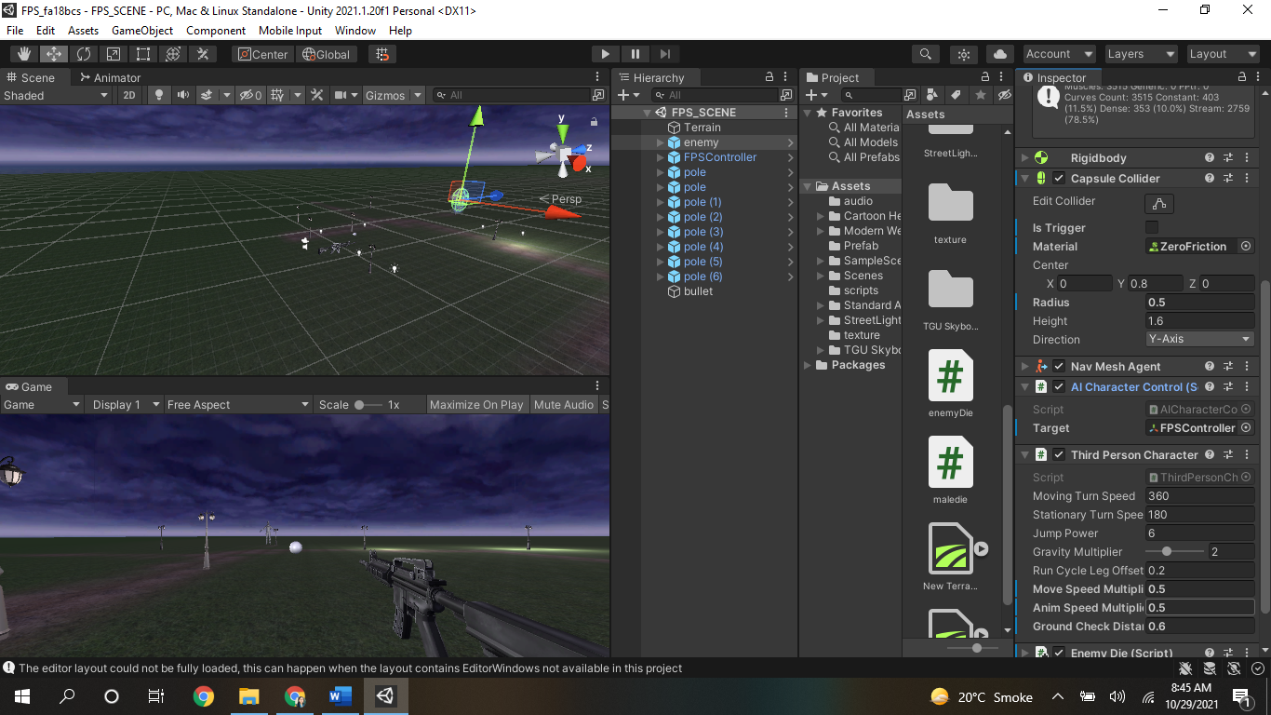

1. Bake Terrian by going into Windows🡪AI🡪Navigation🡪Bake Button
2. Adjust Ground distance of enemy in its inspector
3. Click play to check if Enemy will move towards the FPSController
4. Download MidEvial Warrior Pack from unity store link:

<https://assetstore.unity.com/packages/3d/characters/medieval-cartoon-warriors-90079>

1. Import above characters into your scene for further work in Lab 13-14

Use following script:

BulletController.cs:

using System.Collections;

using System.Collections.Generic;

using UnityEngine;

public class BulletLanucher : MonoBehaviour

{

public GameObject bullet;

// Start is called before the first frame update

void Start()

{

}

// Update is called once per frame

void Update()

{

if(Input.GetMouseButtonDown(0))

{

Instantiate(bullet, transform.position, transform.rotation);

}

}

}

BulletScript.cs:

using System.Collections;

using System.Collections.Generic;

using UnityEngine;

public class bulletScript : MonoBehaviour

{

// Start is called before the first frame update

void Start()

{

}

// Update is called once per frame

void Update()

{

//transform.Translate(0, 0, 1);

Rigidbody r = GetComponent<Rigidbody>();

r.AddForce(transform.forward *100);

}

private void OnCollisionEnter(Collision collision)

{

print("bullet collides");

Destroy(transform.gameObject);

}

}

_____________________________________END__________________________________